**School of Computer Science**

**UNIVERSITY OF PETROLEUM AND ENERGY STUDIES**

**DEHRADUN, UTTARAKHAND**



**System Provisioning and Configuration Management**

**Lab File (2021-2025)**

# **6th Semester**

|  |  |
| --- | --- |
| *Submitted To:*  ***Dr. Hitesh Kumar Sharma*** | Submitted By:  Himanshu Hemant  500091727  B Tech CSE  DevOps[6th Semester]  R2142210350  Batch - 1 |

## Aim: Terraform Multiple tfvars Files.

1. Create a new directory and Create terraform Configuration File (main.tf)

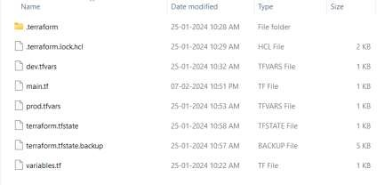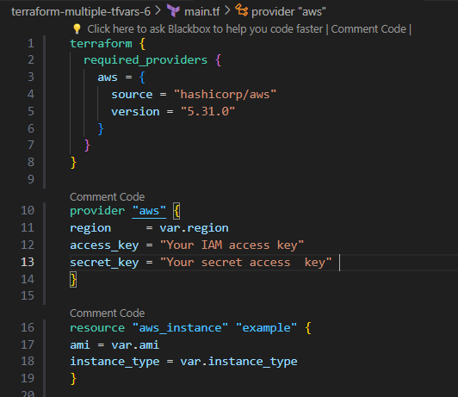

1. Create a file named as “variable.tf”

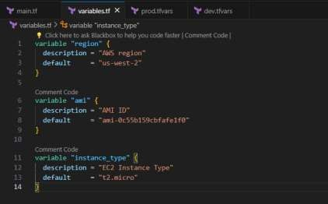

1. Create Multiple tfvars Files:
   1. dev.tfvars
   2. prod.tfvars

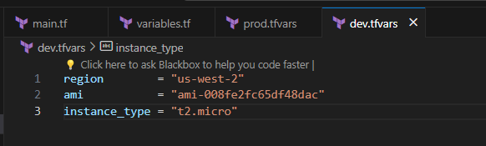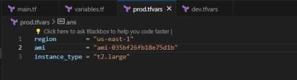

1. Initialize Terraform for Dev Environment and apply it using command “Terraform apply”

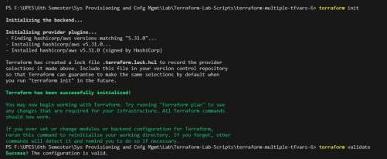

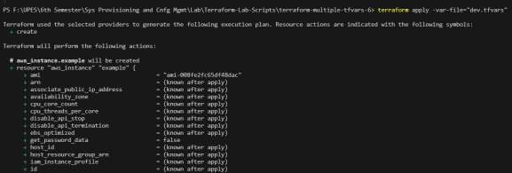

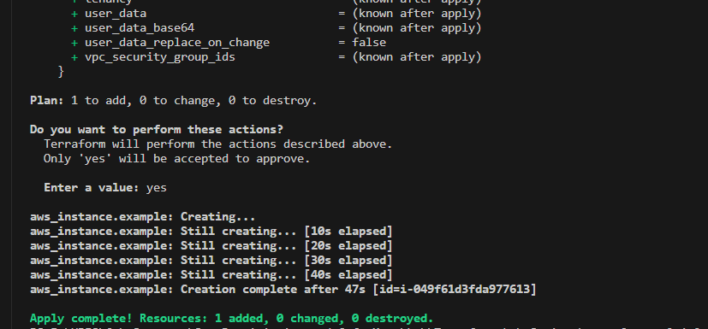

1. Verify Resources on AWS Management Console for Dev Environment

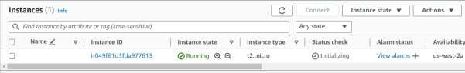

1. Initialize Terraform for Prod Environment and apply it using command “Terraform apply”

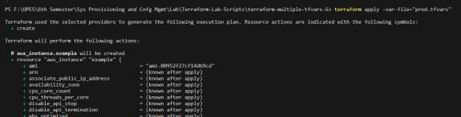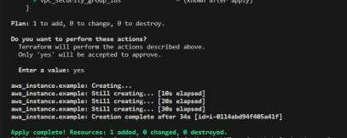

1. Verify Resources on AWS Management Console for Prod Environment

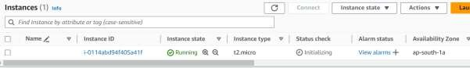

1. Cleanup Resources for Dev and Prod Environment using command “Terraform destroy”

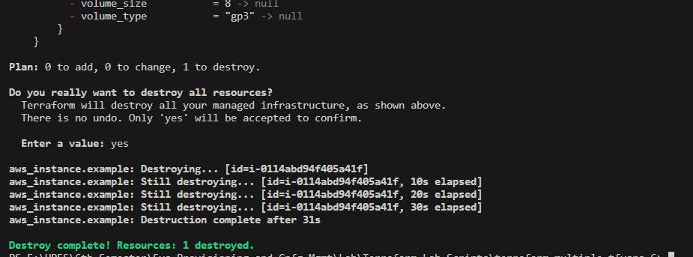

# EXPERIMENT – 7

## Aim: Creating Multiple IAM Users in Terraform.

1. Create a Terraform Configuration File (main.tf)

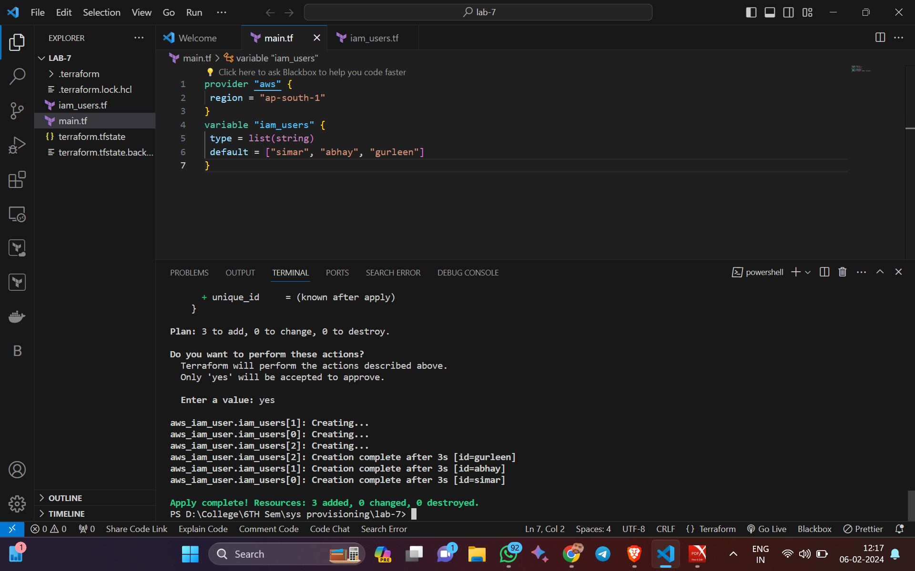

1. Create new file name as “variables.tf”’

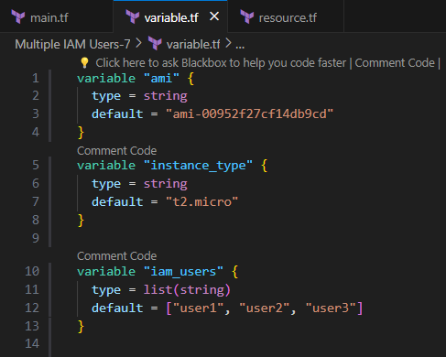

1. Create new file name as “resource.tf”’and define a list variable IAM users containing the names of the IAM users that we want to create.

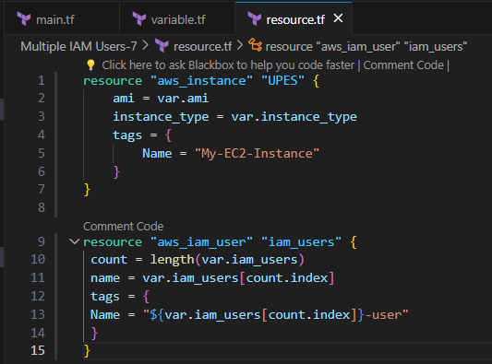

1. Initialize Terraform using command “terraform init”

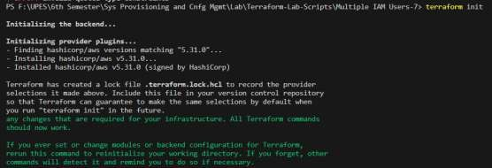

1. Apply it using command “Terraform apply”

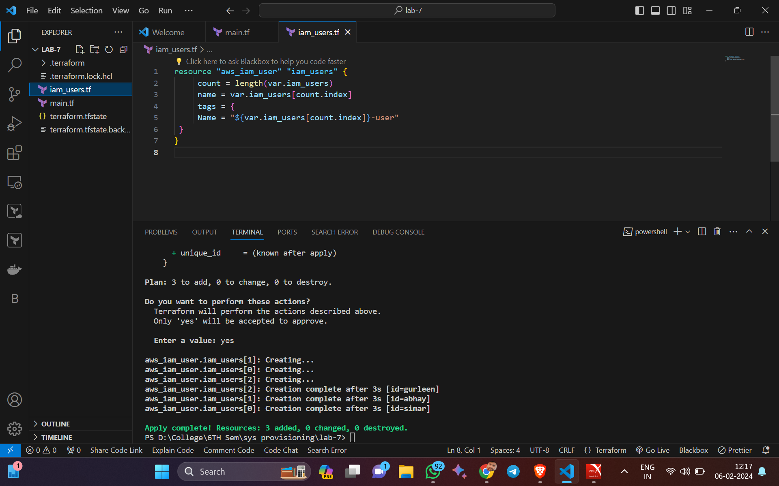

1. Verify Resources on AWS Management Console.

**EC2**

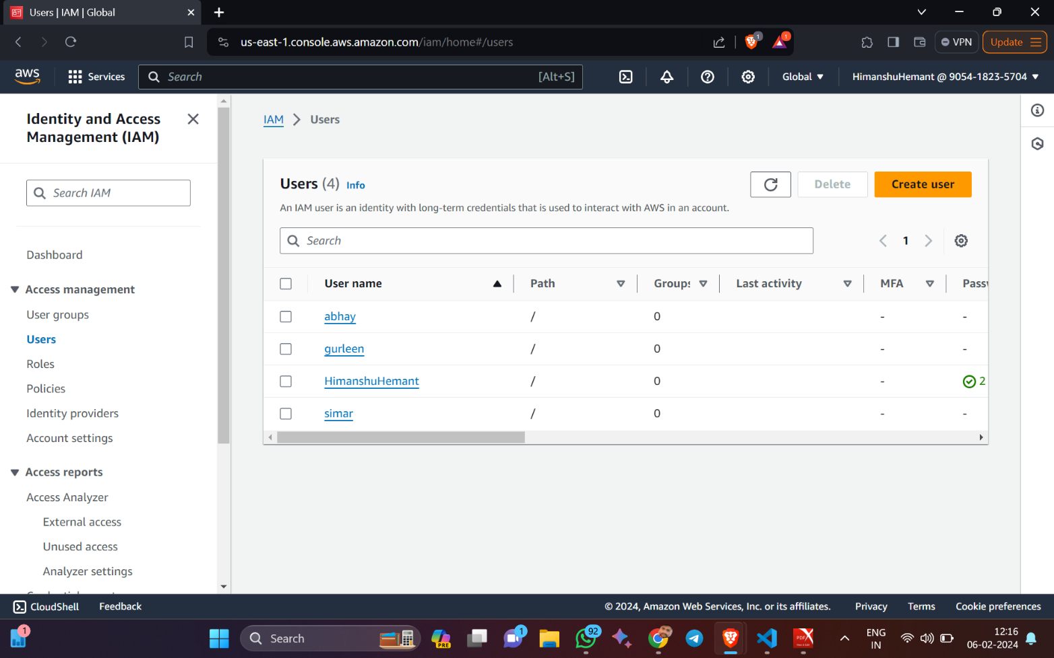

# EXPERIMENT – 8

## Aim: Creating a VPC in Terraform

1. Create a Terraform Configuration File (main.tf)

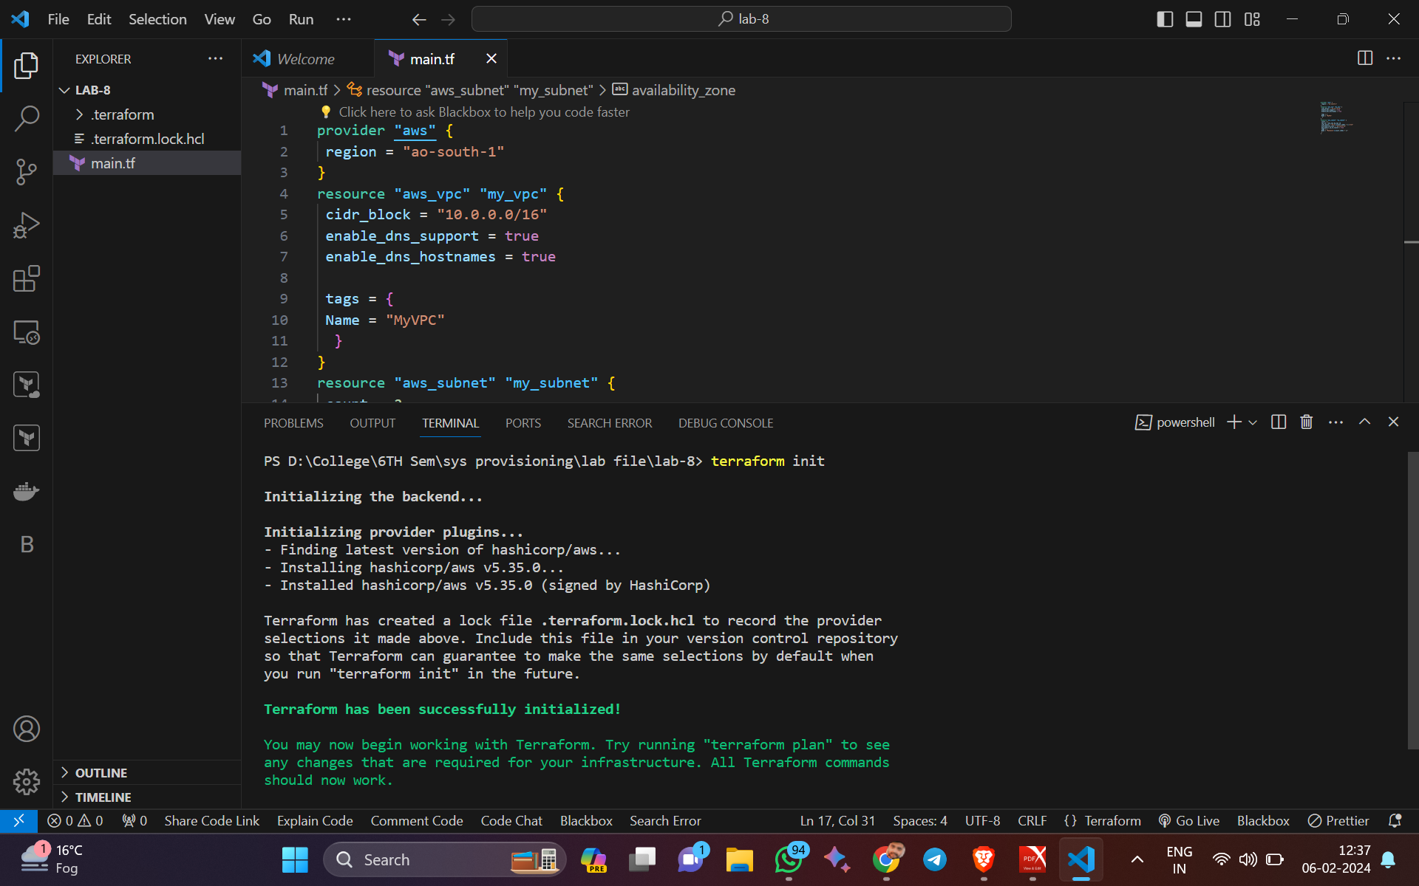

1. Create new file name as “vpc.tf”’

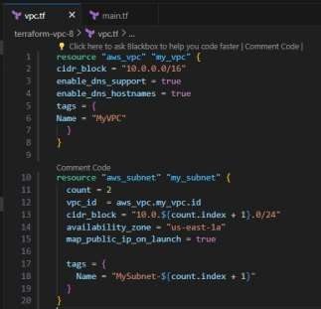

1. Initialize Terraform using command “terraform init”

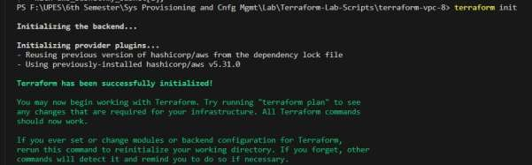

1. Apply it using command “Terraform apply -auto-approve”

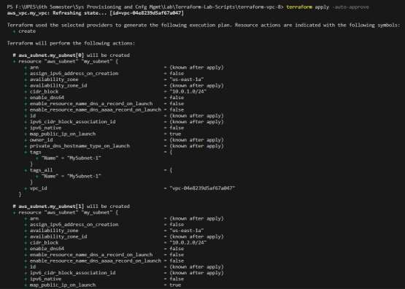

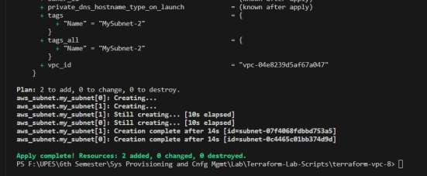

1. Verify Resources on AWS Management Console.

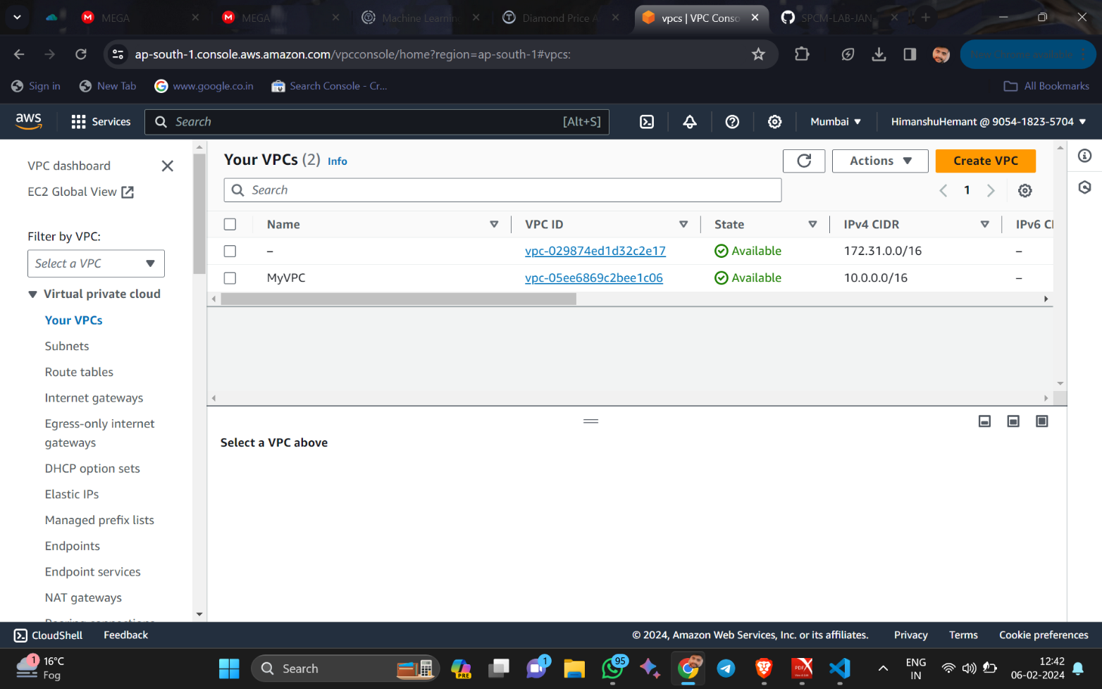 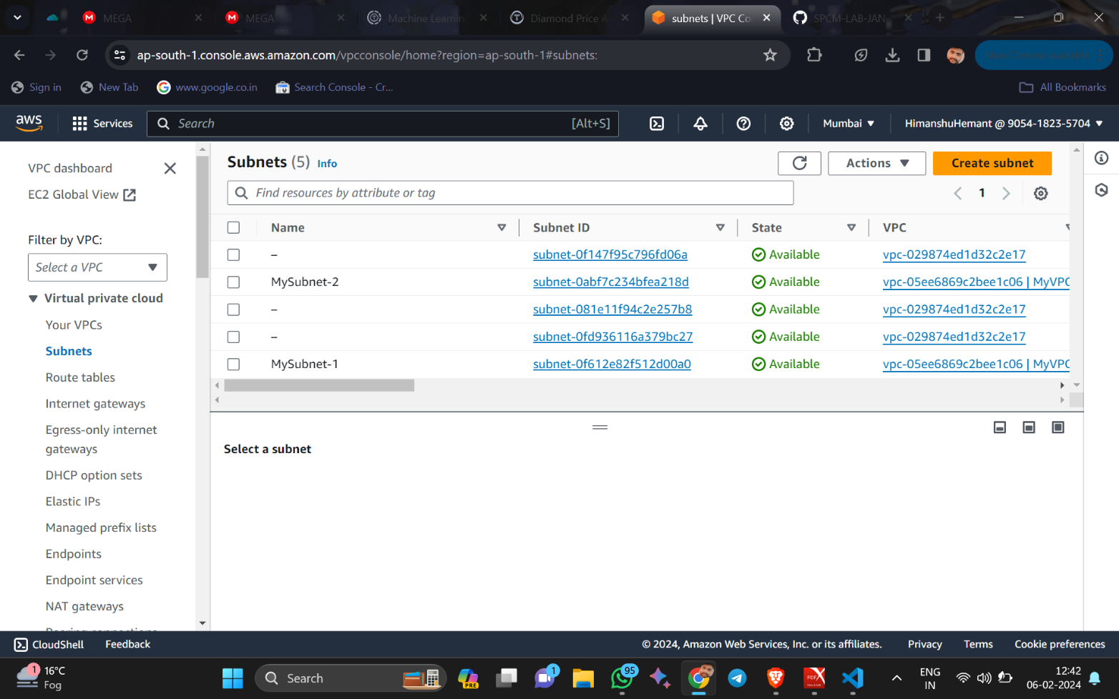

1. Cleanup Resources using command “Terraform destroy”

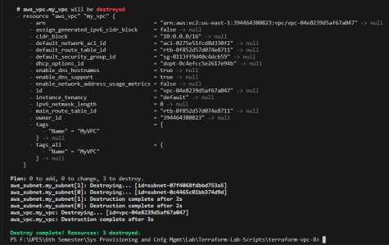

1. Now Update the vpc.tf file and repeat the previous Steps.

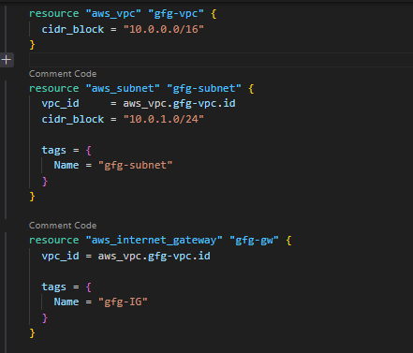

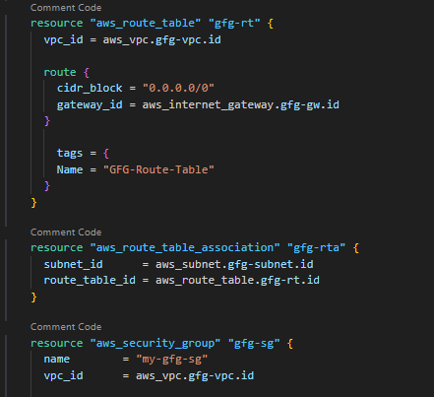

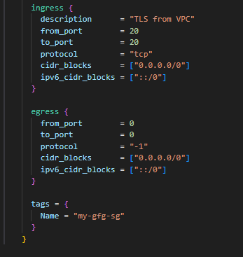

1. Apply it using command “Terraform apply”

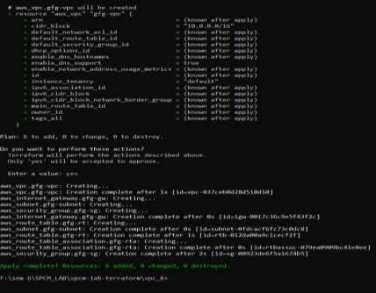

1. Again verify resources on AWS Management Console.

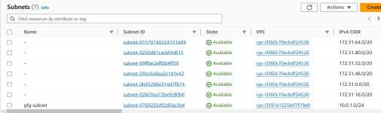

1. Cleanup Resources using command “Terraform destroy”

